Customised Chair or Bed Raise Specification Form
Use this form if you are prescribing: | Custom chair platform/skid raise 50-100mm (cat 1) [complete section A]
 | Custom chair platform/skid raise 100+ mm (cat 2) [complete section A]
 | Custom chair/bed block (specify height) (cat 2) [complete section B]
 | Custom bed platform/raise (cat 2) [complete section C]
For ordering and fabrication of items to the specified dimensions please email this specification form and a completed “Equipment Request Form” to DHSEquipmentProgram@sa.gov.au or Fax to 1300 295 839
Note: Rocker recliner chairs require the locking mechanisms to be locked and may require drilling into base of chair.
Client: Name
Prescriber: Name |  |  |  | Discipline
Prescriber agency: |  |  |  | Phone
Client advised that drilling into the base may be required
Client has given consent to raise chair/bed
Type of chair Rocker/recliner Recliner Standard
(A) Chair platform/skid: Specifications Required (height 50 -100mm cat 1, 100mm + cat 2)
Either (tick box) (tick box)
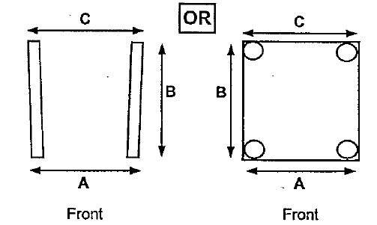 |  |  | Measurements: |  | A mm
 |  |  |  |  | B mm
 |  |  |  |  | C mm
 |  |  |  |  | Height mm
 |  |  | Base of existing chair:
 |  |  | Steel / Wood / Other:
(B) Customised Chair/bed Blocks Specifications (attach diagram if more specific measurements needed):
Block: Raise height: mm |  | Cut out for leg mm X mm |  |  |  | Quantity
(C) Bed skids/customised raise Please attach diagram or photo
Bed dimensions & material:
Skid/raise shape, height & width:

