  - Pressure Reduction/Comfort Chair Assessment Form
Name: |  |  |  |  | Sex: M F |  | Other: |  |  | DOB:
Address: |  |  |  |  |  |  | Phone No:
Clinician: |  |  |  |  |  | Agency:
People consulted:

MEDICAL HISTORY
Diagnosis/Prognosis:
Pain:
Height: |  |  |  |  |  |  | Weight:
Sensation: (note areas that are abnormal or insensate)
Skin History/Integrity: Intact Hx of Pressure Areas Red Areas Open Areas Scar Tissue
(Refer to Braden Scale)
Pressure Relief: Independent Assisted Dependent
Methods Used:
Cushions:
Bladder Management: Continent Incontinent
Bowel Management: Continent Incontinent

SOCIAL HISTORY
Environment (note space for chair, other furniture, floor surface etc.)

Activity Configuration (note time spent in chair, activities to be done in chair etc)

TRANSFERS/MOBILITY

Transfer on and off chair:

Weight shifting in chair:

Does the client have significant contractures or extensor spasm:

Carer needs in assisting client:

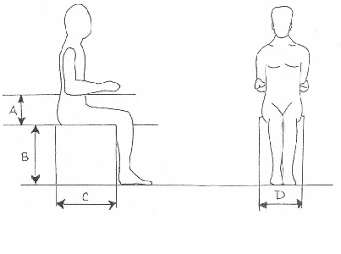BASIC DIMENSIONS:
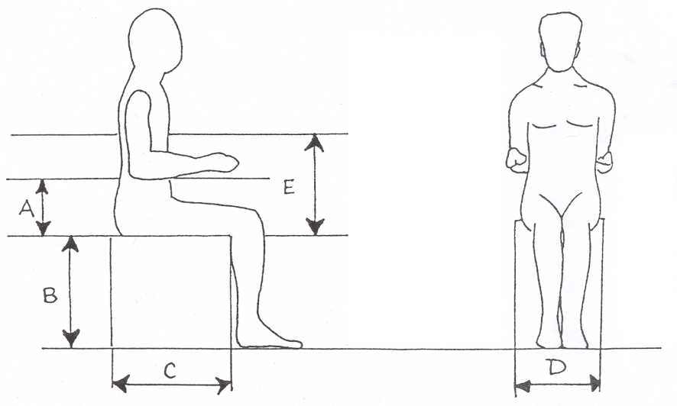
A | Seat - elbow:
B | Back of knee - heel:
C | Posterior of buttocks - back of knee:
D | Widest point at hips or thighs:
Height: |  |  | Weight:

OPTIONS FOR CHAIR
Customisation needed: Yes No Details:
Fabric preference: (vinyl, dartex, synergy, cloth, colour etc.)
Incontinence covers required: Yes No Seat belt required: Yes No
Armrest covers: Yes No Is the chair required for transport in Access Cab or a van: Yes No

CARER/CLIENT GOALS and CONCERNS
Period of Use:

ADDITIONAL NOTES/SUMMARY
Period of Use:
Short term plan(s): | Trial Equipment:
 | Date/Place:
 | Obtain further information:
 | Other:

Info given to client: | Prescription agreement form:
 | “Preventing Pressure Sores” pamphlet

Clinician’s Name:
Clinician’s Signature: |  | Date:

